Quick guide: Risk assessment and controls
This quick guide complements the Risk assessment for COVID-19 guidance and is adapted from the Health and Safety at Work Act 2015 practical guide.

It can be used to support your risk assesment and health and safety review.

Role of the board as PCBU
The Person Conducting a Business or Undertaking (PCBU) is usually a legal or corporate entity, including a self-employed person. In a school the PCBU is the board.
As the PCBU, the board holds the primary duty of care to ensure the health and safety of everybody involved with the school “so far as is reasonably practicable”.
The board usually delegates the implementation of health and safety policy to the principal, who develops appropriate procedures and practices to ensure obligations and expectations are met. The board may delegate any of its functions or powers but can never delegate its accountability.
Even if your school already has good health and safety management in place, with the changes to the vaccine mandate and My Vaccine Pass, it is recommended that you review it and ensure that it reinforces an active culture among all those at the school, including ākonga.
A formal risk assessment enables the board to understand what the significant hazards in their school are. More importantly, it helps the board to focus on the significant risks, rather than using their resources trying to manage every risk.

Managing risks
Risks must be managed by taking action to eliminate them, and if that is not reasonably practicable, minimising them. Eliminating a hazard will also eliminate any risks associated with that hazard.
- Hazard = a situation or thing with the potential to cause death, injury or illness
- Risk = the likelihood that death, injury or illness might occur when exposed to a hazard
Risk assessment involves considering the severity of consequences if a person is exposed to a hazard, combined with the likelihood of it happening. The level of risk will increase as the likelihood of injury/illness, or it’s severity, increases.
A risk assessment can help determine:
- how severe a risk is
- whether existing control measures are effective
- what action you should take to control the risk, and
- how urgently the action needs to be taken
Assessing risks
The information below can help you to assess the severity of the consequences and the likelihood of injury or illness occurring, and then to assess the risk for each hazard.
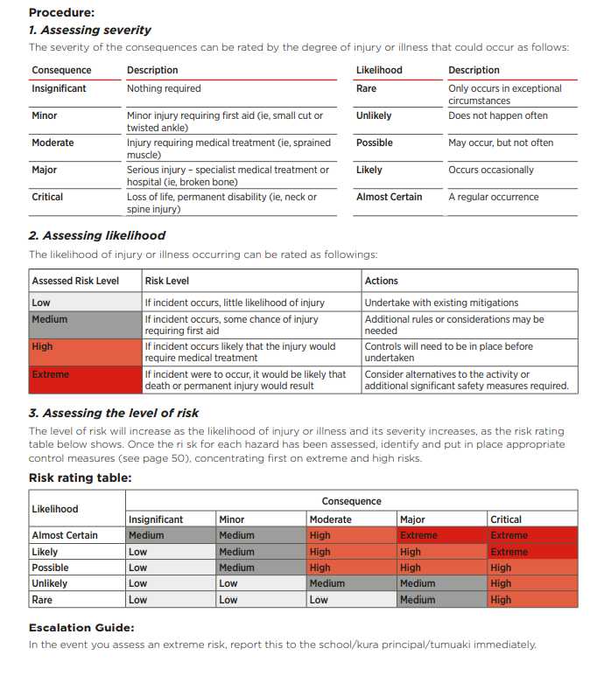
NB this content is copied directly as an image from the Health and Safety at Work Act 2015 practical guide (Tool 13 on page 57). Page 50 as noted below, refers to the guidance document.
.
Risk register template
Refer to the above information to determine Likelihood, Consequence and Risk Rating. The content in Red below will not necessarily reflect your own risk setting. It is an example only. See further below for considerations to inform your thinking about risks in your own school context.
Risk description | Potential Harm | Consequence | Likelihood | Risk rating | Eliminate, isolate or minimise | Risk controls | Training or information required | Date checked
Exposure to Omicron variant of COVID-19 | For the majority of people it will be a mild to moderate illness that can be managed at home. Commonly, children have mild or no symptoms of COVID-19 with a short duration of illness.  The incidence of severe or fatal disease in children is significantly lower than in adults.  A very small proportion of the population are at risk of hospitalisation and for a very small proportion COVID-19 can lead to death. | Minor to moderate – for majority  Major to critical – for those at very high risk of severe illness | Likely  Rare | Medium  Medium - High | Minimise  Minimise | See the Risk Assessment guidance for a list of controls that you can implement at the different framework settings. You may already have many of these controls in place at Red under the framework and will have a highly vaccinated staff. For example, in a primary school setting:  - Staying away if unwell and getting tested  - Monitoring for symptoms and asking those unwell to go home  - Using well-ventilated spaces  - Good hygiene and cleaning  - Encouraging and supporting all staff and eligible students to get vaccinated including booster doses  - Grouping students to minimise spread across different classes  - Masks required for children, students and staff in years 4 and up, when indoors (unless exempted)  - Limiting onsite visitors to only those who are essential  - Limiting large gatherings  - Holding higher-risk activities outdoors, where possible  For children with multiple chronic conditions and staff or children who have an underlying medical condition which puts them at higher risk from COVID-19, and regardless of their own vaccination status:  - develop an individual plan to support safety onsite  - encourage staff to wear a medical-grade mask when indoors regardless of year level (and as required when at Red as noted above)  - staff working in regular close contact with children/young people at higher risk when indoors, will be required to be vaccinated  - encourage them to seek advice from GP or other health professional about how to best manage risk |  | xx/04/22
Poor lifting technique | Could lead to a back injury |  |  |  |  | - Develop and review policy regularly  - Training needs analysis including lifting/manual handling  - Identify tasks that require lifting  - Seek assistance for heavy lifts  - Provide a trolley  - Refer to WorkSafe publication, Code of Practice for Manual Handling
Storing and using chemicals  e.g. solvents, paints, fire, fumes, inhalation | Risk of injury, illness or in worst case, death. |  |  |  |  | - Develop and review policy regularly  - Replace toxic chemicals with non-toxic substitutes if possible  - Store hazardous chemicals in locked cupboard  - Use with good ventilation  - Comply with The Hazardous Substances and New Organisms (HSNO) Act 1996

Monitor and review
Once the controls have been implemented, they must be regularly monitored and reviewed to ensure they are effective. The relevant school leader is expected to do this in consultation with workers. The regularity will depend on the risk rating.
The principal collates all risk registers on a regular basis for board reporting. The PCBU has to consider what is reasonably able to be done in relation to ensuring health and safety, taking into account and weighing up all relevant matters such as the likelihood of, and consequence of harm occurring, and the availability and suitability of ways in which to eliminate or minimise the risks.

