Managing COVID-19: A public health toolkit for tertiary providers at Phase 3
Version 4 – Released 13 April 2022

Purpose and overview of this toolkit
This toolkit is intended to be used as a national tool for tertiary providers and education agencies operating under the COVID-19 Protection Framework.
Omicron is changing the approach to managing COVID-19 cases and contacts. The government announced a three-phase approach to the Omicron response on 26 January 2022.
This toolkit provides information to support tertiary providers to manage COVID-19 within their settings at Phase 3 of the Omicron response.
At Phase 3, only confirmed COVID-19 Cases and Household Contacts of a confirmed Case are required to self-isolate. Other Close Contacts are not required to self-isolate, but may choose to do so.
At Phase 3, providers are not required to undertake Close Contact identification in the tertiary setting. However, providers may choose to undertake this process and may ask Close Contacts to consider learning or working remotely for a period of time to help slow the spread of COVID-19 in the tertiary community. Individuals and their communities can make decisions based on their circumstances.
While Close Contact identification is not required at Phase 3, the preventative measures outlined in this toolkit (ventilation, mask use, etc.) should still be in place to reduce the spread of COVID-19, including the specific requirements under the Red setting of the COVID-19 Protection Framework.
This guidance has been informed by international recommendations, which note the need for a pragmatic approach, balancing risks and the limited evidence about the options proposed.
The toolkit has been prepared by Manatū Hauora | the Ministry of Health and public health units, in consultation with Te Tāhuhu o te Mātauranga | the Ministry of Education, the Tertiary Education Commission (TEC) and the New Zealand Qualifications Agency (NZQA).
As the COVID-19 situation develops, this toolkit may be amended or revised. This version of the toolkit does not include guidance on managing public health risk in Tertiary Accommodation, as separate guidance for this setting has been issued by the Ministry of Health (link).
For any additional information, please visit www.health.govt.nz or www.covid19.govt.nz.

Contents
Managing COVID-19: A public health toolkit for tertiary providers at Phase 3 1
Purpose and overview of this toolkit 1
Contents 2
Guiding principles 3
Preparedness: How to reduce the risk of COVID-19 4
The COVID-19 Protection Framework 5
Keep a track of who visits your sites 5
Vaccination 5
Ventilation 6
Mask use 6
Guidance for moving to online learning, if required 8
Additional information 8
Process for case and contact management at Phase 3 9
Advice for categorising contacts within a tertiary provider 11
Information sharing and privacy 14
Appendix One: Template communications for students, staff/kaimahi and wider community 15
Appendix Two: Social media template: Tertiary provider informing community about confirmed case 23
Appendix Three: Checklist for preparedness 24
Appendix Four: Frequently asked questions 26
Appendix Five: Scenarios to support contact categorisation 28

Guiding principles
- The risk of COVID-19 in tertiary settings can be reduced through implementing public health measures. Following the procedures and process set out in this toolkit will help to lower the risk of COVID-19 spreading on tertiary sites. It also fulfils part of providers’ health and safety obligations, and their obligations under the code of practice for pastoral care for all students, including those students in tertiary student accommodation.
- Tertiary education providers should have completed a thorough risk assessment of their wider premises and should have developed and implemented processes for operating at each setting of the COVID-19 Protection Framework. Risk assessments may need to be updated over time to ensure they reflect current public health guidance. Providers should continue to provide staff and students with information about actions they can take to reduce transmission of COVID-19 included in this toolkit, such as following mask requirements, physically distancing where possible, and ventilating spaces.
- From 11.59pm on Monday 4 April 2022, the Government no longer requires staff, students, or visitors who are onsite at a tertiary premises to hold a My Vaccine Pass (MVP) at any setting of the Framework.
- At Phase 3 of the Omicron response only confirmed COVID-19 Cases and Household Contacts of a confirmed Case are required to self-isolate. Other Close Contacts are not required to self-isolate, but may choose to do so.
- At Phase 3, providers are not required to undertake Close Contact identification in the tertiary setting. However, providers may choose to undertake this process and may ask Close Contacts to consider learning or working remotely for a period of time to help slow the spread of COVID-19 in the tertiary community.
- Particular focus should be given to those students or staff who may be at higher risk of severe illness due to COVID-19.
- There are significant benefits for people to be able to participate in tertiary education, from educational and social perspectives. This approach aims to support the continuation of learning within tertiary settings across the country.

Preparedness: How to reduce the risk of COVID-19

There are many things that tertiary providers can do to further reduce the risk and impact of a COVID-19 case in their environments. It is useful to conceptualise this as having layers of preventative measures in place to protect staff and students, as the cheese model below explains. The more layers of protection in place (eg, vaccination, ventilation, masks etc.), the harder it is for the virus to get through.
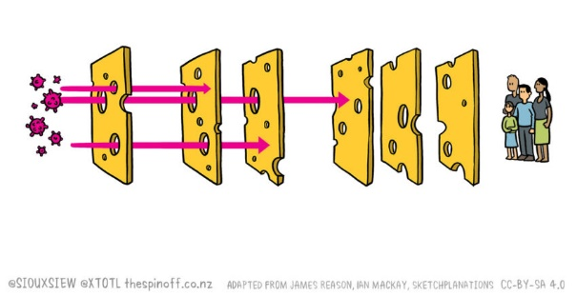

While tertiary education providers are not required to at Phase 3, providers may choose to undertake Close Contact identification and may ask Close Contacts to consider learning or working remotely for a period of time to help slow the spread of COVID-19 in the tertiary community.

To help reduce the risk of spreading COVID-19, at Phase 3 we recommend that tertiary providers:
- Support access to COVID-19 vaccinations for all staff and students and encourage boosters as the best thing you can do to protect against Omicron
- Encourage the use of the Bluetooth function on the COVID-19 Tracer app
- Keep occupied spaces well ventilated
- Create a culture where wearing a mask is normalised
- Maintain physical distancing as much as possible
- Encourage good hygiene practices, including hand hygiene and cough and sneeze etiquette
- Maintain appropriate cleaning regimes, including cleaning and disinfecting high touch surfaces, as well as regular cleaning
- Advise students and staff members with COVID-19 symptoms to get a rapid antigen test (RAT) and remain at home until a negative result is received (if done through PCR test) and they are symptom free for 24 hours
- Reduce mixing of students, staff and visitors

The COVID-19 Protection Framework
For guidance about how tertiary providers can operate safely in the different settings of the COVID-19 Protection Framework (the traffic light system), please visit:
- Te Mahau | COVID-19 Protection Framework for tertiary and international sector

For general information about the COVID-19 Protection Framework, please visit:
- Unite against COVID-19 | COVID-19 Protection Framework (traffic lights)

The webpages above provide information on key public health measures, including vaccination, mask use, and capacity limits. Some more information about some of these public health measures is below.
Tertiary providers are expected to have undertaken a risk assessment of their teaching and learning environments and wider premises, and developed plans for operating at each setting of the COVID-19 Protection Framework, including making revisions based on and implementing any additional public health measures that may be appropriate.

Keep a track of who visits your sites
Tertiary providers are no longer required to enable people to record their visit (for example through displaying COVID Tracer QR codes).
However, providers should retain capability to swiftly reinstall COVID Tracer QR codes in case these are required again in future. There is no longer a requirement to offer alternative forms of recordkeeping (for example paper-based).

Vaccination
From 11.59pm on Monday 4 April 2022, the Government no longer requires staff, students, or visitors who are onsite at a tertiary premises to hold a My Vaccine Pass (MVP) at any setting of the Framework.
We are now overall a highly vaccinated country. Vaccine requirements like MVPs and mandates played an important role in getting us there. They have done the job they were put in place for.
Tertiary providers may wish to continue to use MVPs as a condition of entry for students or visitors, unless this is prevented by contractual or legislative provisions, such as Government mandated ‘prohibited settings’, statutory rights of access, or prohibitions on discrimination under the Human Rights Act 1993.
Tertiary providers may also wish to continue to require their employees (or contractors) to be vaccinated to perform certain types of onsite work. This decision would need to be based on an updated health and safety risk assessment which reflects current public health advice.
We note the complex environment tertiary education providers need to make these decisions in. This environment includes providers’ human rights obligations, health and safety requirements, expectations for learner wellbeing and safety systems, contractual relationships with students, student enrolment entitlements, the tertiary and international code of practice, and equity considerations.
We recommend that in cases of doubt you seek appropriate health or legal advice, particularly if you are considering continuing with vaccination requirements now that the Government mandated requirements are removed from the COVID-19 Orders.
The Ministry of Business, Innovation and Employment and WorkSafe have updated guidance for businesses (including tertiary providers) to assist with developing or updating their plans for vaccination requirements:
- Vaccines and the workplace – employment.govt.nz
- How to decide what work requires a vaccinated employee — worksafe.govt.nz
- Our enforcement approach during the COVID-19 pandemic — worksafe.govt.nz

Ventilation
Open or well-ventilated spaces reduce the risk of transmission of COVID-19 because infectious particles are more quickly diffused in the open air than in spaces with less ventilation. Tertiary education providers should consider how ventilation can be used to reduce risk in their teaching and learning environments.
Transmission of COVID-19 is more common indoors, where there may be less space to physically distance, and where people may come into contact with droplets and aerosolised particles more easily. The virus that causes COVID-19 can be spread from person to person through contact with droplets, which are produced when a person sneezes or coughs, or through other small respiratory particles that are produced when people talk, sing or shout. These small particles can remain in the air for some time. Aerosolised particles may build up if there is not enough ventilation.
To help reduce the risk, it is important to take steps to improve ventilation in indoor settings so that any infectious particles that may be present in the air are more quickly removed. Providers should consider options for ensuring spaces are kept well ventilated, for example ventilating the space between classes or ensuring a space is ventilated every two hours.
For information on ventilation in school environments, please see Te Mahau | Ventilation in schools. Much of this is applicable to tertiary settings also.

Mask use
At the Red setting of the COVID-19 Protection Framework, masks must be used indoors at tertiary education premises in areas that are open to the public, and during formal teaching and learning activities, unless an exemption applies. Mask use is also recommended at Green, and strongly recommended at Orange, particularly for higher risk situations.
At Red, it is also strongly recommended that masks be a medical-grade mask (for example, a Type IIR/Level 2 mask). This is particularly important for teaching and learning that involves a practical element where staff and/or students are coming into close contact with one and other.
The widely available ‘blue’ mask is an example of a medical grade mask. Providers should consider if there are particular staff roles for which particular types of masks should be worn. Cloth masks that fit well continue to be an option for staff and students in tertiary settings.

There are some exceptions to the mask requirement. For example, those who have a physical or mental illness or condition or disability that makes wearing a mask unsuitable are exempt.

What is an appropriate mask?
Effective mask use by everyone can significantly reduce the risk of spreading COVID-19 to others.
A mask should fit securely, covering the nose and mouth and needs to be an actual mask. This means scarves, bandannas, or t-shirts should not be used.
There are many types of masks available, including cloth and disposable. Masks work best if they are made with multiple layers and form a good fit around the face.
Appropriate mask: fitted snugly and sealed well around facial contours | NOT appropriate mask
Single use, disposable masks (medical masks)  Re-usable fabric masks with 3 layers | Dust masks  Bandanas (or similar, eg, scarves, t-shirts)

Cloth masks should be made of a material that you find comfortable and breathable, such as cotton. The World Health Organisation recommends three layers of fabric. Manatū Hauora | Ministry of Health recommends you should have enough (washable) masks so each person in your family can wear one and wash one.
More information about use of masks, including appropriate types of masks, can be found at Ministry of Health | Types of face masks.

Special considerations for masks
The use of masks may have a particular impact on those who rely on visual signals for communication. Those who communicate with or provide support to this group of people are exempt from wearing a mask. They may choose to wear a face shield instead, but this will not significantly reduce the risk of spreading COVID-19.
If you have staff or students who are not wearing mask, it’s reasonable for you to check whether they are exempt from doing so. It’s not always obvious why a mask is unsuitable for someone, so it’s important to be kind, respect people’s privacy, and not jump to any conclusions.
Exemption cards are available only for those who have a disability or health condition that makes wearing a mask unsuitable. While the cards are not a requirement for the individual, guidance on the Ministry of Health website notes it will make it easier to explain why wearing a mask is unsuitable for them.
If a staff member or student has an exemption card, they will be able to show that to you as evidence of exemption. If they don’t have a card, they may be able to provide a letter or medical certificate from a health practitioner or GP.
Organisations which can provide an exemption card are:
- Disabled Persons Assembly NZ – 04 801 9100 or info@dpa.org.nz
- Blind Citizens NZ – 0800 222 694 or admin@abcnz.org.nz
- Deaf Aotearoa – covid@deaf.org.nz
There are many layers of protection in tertiary settings, including people who are unwell staying away, increasing rates of vaccination and boosters across the population, good ventilation, most students and staff wearing masks, good cough and sneeze etiquette.
Therefore, where someone is exempted from wearing a mask, they should not be prevented from attending a tertiary education provider and nor should there be any additional measures imposed on the individual.

Guidance for moving to online learning, if required
As the number of confirmed Cases within the tertiary community grows, providers will need to determine for themselves the appropriate mix of online and in-person provision based on their risk assessments, health and safety obligations, and impacts on staff and students. Providers should notify their single point of contact (TEC or NZQA) if they are moving partially or fully online.

Public health may be involved in some high-risk outbreaks, particularly in hostels or halls of residence, if resources allow. If public health advises a provider to move online, providers should follow this advice.

Providers may want to consider the following questions when deciding if they should move to full or partial online provision:

  - Are there sufficient levels of staff able and willing to come on site to open and operate the campus? This may include tutors to deliver the courses, maintenance staff, student support and advisory staff, library staff, and administration staff.

  - How many students are able to or willing to come on site? There may be a high proportion of students who are isolating as Cases or Household Contacts and others may not feel safe to attend class in person. In these scenarios, it may be beneficial to deliver courses online, if possible.

  - Are there courses that can’t be delivered online, or students who can’t access online delivery? What will the impacts be on the students that are affected? Can you mitigate these in some way, eg deliver some classes in person with public health measures?

  - Are you meeting the health and safety obligations to workers and students when they are on site? Are Student Health Services available to all students? What is the risk profile of your staff and student community?

How effective are the public health mitigations you have implemented on site? What other mitigations could you put in place to make it safer for people to be onsite (for example, improving ventilation)?

Process for case and contact management at Phase 3
There are already likely to be a number of confirmed COVID-19 Cases who have been onsite at a tertiary education facility or who are currently living within tertiary student accommodation.
At Phase 3 of the Omicron response, only confirmed Cases and Household Contacts of a confirmed Case are required to self-isolate. Other Close Contacts are not required to self-isolate, but may choose to do so.
At Phase 3, providers are not required to undertake Close Contact identification in the tertiary setting. However, providers may choose to undertake this process and may ask Close Contacts to consider learning or working remotely for a period of time to help slow the spread of COVID-19 in the tertiary community. Individuals and their communities can make decisions based on their circumstances.
Providers who choose to undertake Close Contact identification at Phase 3, can continue to follow the process and guidance in this toolkit and will be supported by the relevant Single Point of Contact for their tertiary education provider in this process (if the provider required support).
Single points of contact (SPOC) for tertiary providers (including private student accommodation providers) are as follows:
- NZQA: Private Training Establishments
- Tertiary Education Commission: Tertiary Education Institutions
From Tuesday 12 April 2022, SPOCs can be reached working days between 10am to 4pm, via email. Contact details are as follows:
NZQA: SPOC@nzqa.govt.nz | TEC: SPOC@tec.govt.nz

Process flow chart for Phase 3 (Optional)
Under Phase 3, Cases will be notified by text message and where possible complete an online investigation. Household Contacts will be advised they are Household Contacts and need to isolate via text. If a provider chooses to undertake Close Contact identification, SPOCs can support this process. Public health units may provide support for outbreaks in some high-risk settings (e.g. tertiary student accommodation).
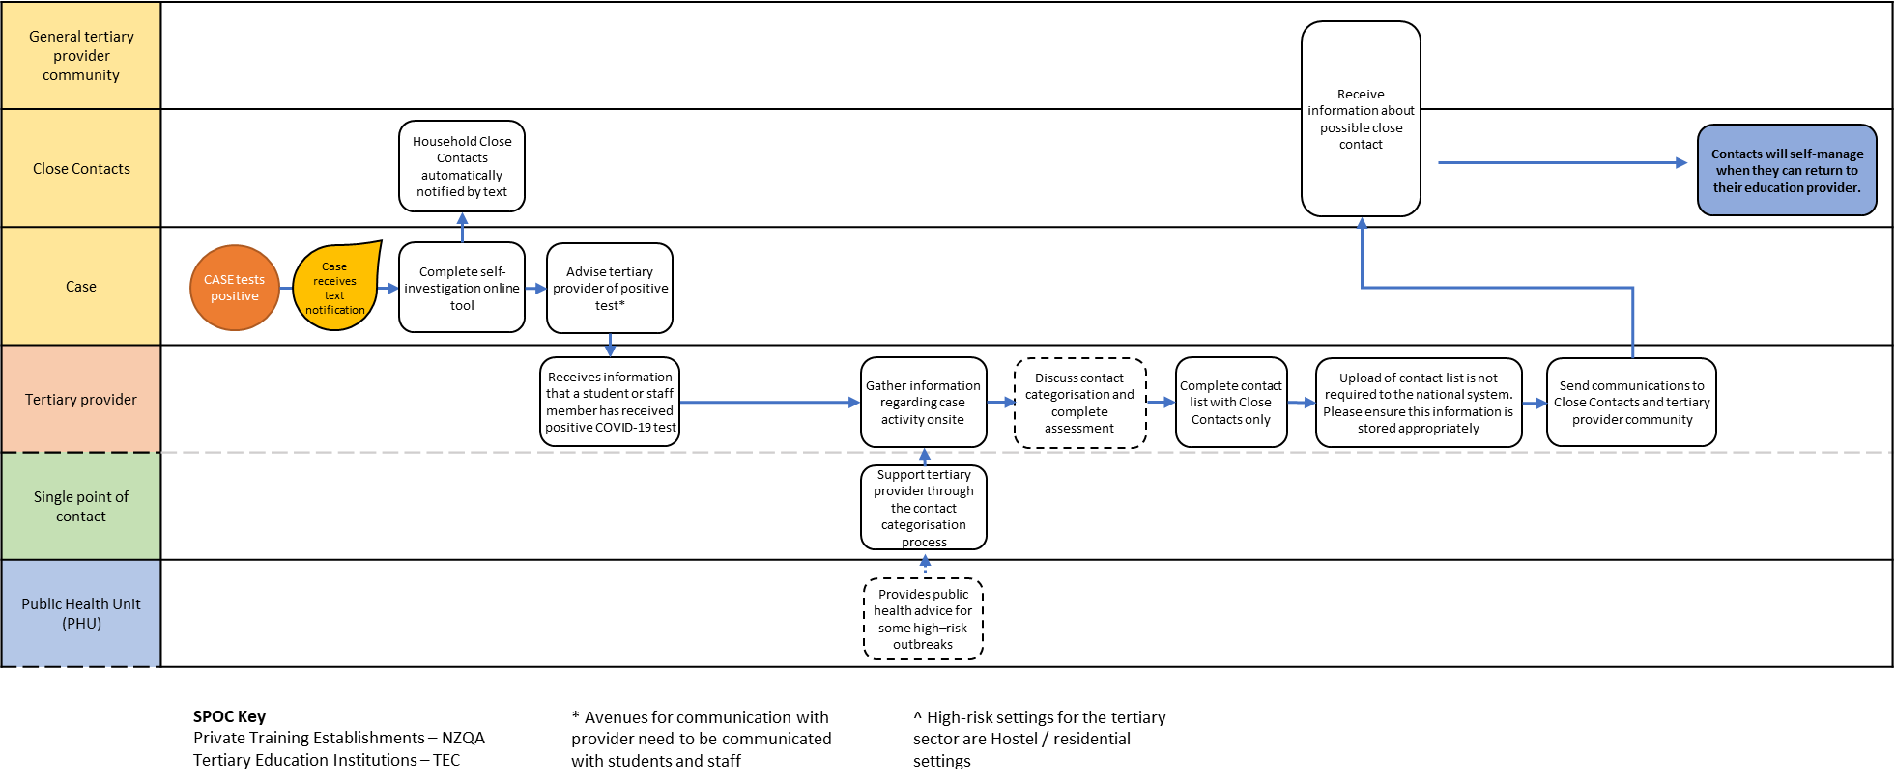

Advice for categorising contacts within a tertiary provider
Phase 3 of the Omicron response
At Phase 3, providers are not required to undertake Close Contact identification in the tertiary setting. Providers who choose to undertake Close Contact identification at Phase 3, can continue to follow the process and guidance in this below.
Contact categorisation
People who have come into contact with a Case are considered ‘Contacts.’ Contacts are categorised based on their exposure, depending on the type of interaction they may have had with the COVID-19 case, and whether the case was wearing a mask at the time.

Contacts may be categorised as either:
- Household Contacts – must self-isolate (see guidance for Tertiary student accommodation) ; or
- Close Contacts – not required to self-isolate, but should monitor for COVID-19 symptoms; or
- Casual Contacts – limited exposure to the Case, no action required.

When someone is a COVID-19 Case, their infectious period should be assumed to be from 48 hours before onset of symptoms. If a case is asymptomatic, they should generally be assumed infectious from 48 hours before the initial test.

When Contacts are identified, the last time that a Contact was near to the case during their infectious period is considered their ‘last date of exposure’. This date is known as day 0, and used to calculate the days for isolation and testing.

If a provider chooses to undertake Close Contact identification (which is not required at Phase 3), their risk assessment process should consider the size of the indoor space, duration of contact, distance between Case and Contact, ventilation of the space and whether the Case was wearing an appropriate mask.

The Contact Categorisation Table set out below can help to distinguish the risk in different settings, based on public health advice. The scenarios outlined below can also help support providers who choose to undertake Close Contact identification.

It is important to emphasise that if providers do identify Close Contacts, at Phase 3 there is no legal requirement for these Close Contacts to self-isolate. Providers may ask Close Contacts to consider to learn or work remotely for a period of time to help slow the spread of COVID-19 in the tertiary community, but it should be made clear to the Contact that they are not legally required to isolate (unless they are also a Household Contact or have been directed to isolate by a Medical Officer of Health).

Contact Categorisation Table
If the provider chooses to undertake Close Contact identification, the Contact Categorisation table below provides the public health risk assessment for categorising contacts.

Key notes:
- Consistent use of a mask by a Case will minimise the likelihood that other staff or students are Close Contacts. Wearing a mask for the entire day is very difficult. Short time periods without wearing a mask (less than 15 minutes) will not change the categorisation of other contacts in the same space, unless the case was coughing, sneezing or shouting at the time (see first box).
- Whether someone is vaccinated or not will not change someone’s contact category.
- Other types of interactions not described in the table below are considered ‘low risk’ and the contact will be ‘Casual’. There is no action required for Casual Contacts.
- At Phase 3, providers are not required to undertake Close Contact identification, and Close Contacts are not required to self-isolate (unless they are also a Household Case).

 | Type of interaction | Examples | Mask worn by case
 |  |  | Yes | No or unknown
Close range contact within  1.5m of case | Direct contact with respiratory secretions or saliva (indoors or outdoors) OR  Face to face contact with a case who is forcefully expelling air/secretions  FOR ANY DURATION OF TIME REGARDLESS OF MASK USE | Kissing, spitting, hongi, sharing cigarettes or vapes  Singing, shouting, coughing, sneezing  Contact sports (heavy breathing related to exertion) | Close | Close
 | Indoor face to face contact for more than 15 minutes | Having a conversation  Sitting across a table from someone | Casual | Close
 | Non-face to face contact for more than 1 hour in an indoor space | Sitting near someone in class or assembly but not having a conversation | Casual | Close
Higher risk indoor contact more than 1.5m away from case and no close-range contact | Indoor contact in a small space without good airflow/ventilation* for more than 15 minutes | Class or tutorial room, staff rooms, office, sick bay, toilets, minivan or bus (provided by the provider) | Casual | Close
 | Indoor contact in a moderate sized space without good airflow/ventilation for more than 1 hour | Lecture theatre, research lab, gymnasium, hall, train | Casual | Close
*Good air flow and ventilation is required to prevent virus particles accumulating in an indoor space. Good ventilation/airflow can be achieved by keeping windows open.
Appendix five sets out a range of tertiary-based scenarios to support providers in determining Close Contacts of a Case (if they choose to undertake this process).

Key questions to ask when identifying contacts
Where providers choose to undertake Close Contact identification at Phase 3, the questions below will help with thinking about who a case interacted with and start to determine who may be a contact.
Who is the case? | Key questions
A student is a case  All students/staff who were in indoor environments with the case will be assessed to determine if they are a contact | - Was the Case wearing a mask (if so, most contacts would be considered Casual Contacts)?  - Who was in the class/es, labs, study spaces, shops, hospitality businesses etc with the case? (Staff, students or visitors)  - Who was sitting or working near to the case in class, labs, study spaces?  - What other class/es, labs, events did the case attend?  - Who shared a meal with the case?  - Any other staff members they have had close contact with?  - Any other students or visitors they have had close contact with?
A staff member is a case  All students/staff who were in indoor environments with the case will be assessed to determine if they are a contact | - Who was in the class/es, labs, study spaces, offices, workplace etc with the case?  - Who was in meetings with the case?  - Who was in the staffroom with the case?  - Any other staff members they have had close contact with?  - Any other students they have had close contact with?

Spreadsheet to assist with contact categorisation
The Ministry of Health has developed a spreadsheet for education settings with an embedded algorithm that can assist with contact categorisation. Providers are not required to use this spreadsheet but may do so if useful. The spreadsheet can be downloaded here.
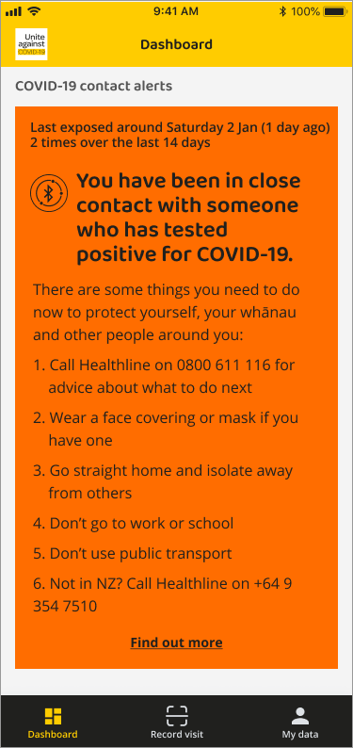
Bluetooth function of the NZ COVID Tracer App
If a student or a staff member receives a Bluetooth notification from the NZ COVID Tracer App, they should follow the directions in the App notification.
You will also be able to find up-to-date guidance on what contacts need to do, including isolation periods, on the COVID-19 Health Hub website.

Information sharing and privacy
Provision of information relating to those that may have been exposed to COVID-19 is important for controlling transmission of the virus, as outlined in the Health Act 1956. If information for identified contacts is collected and provided to the Public Health Unit and the Ministry of Health, this personal information will only be used for public health purposes and personal information will not be disclosed.

Contact information is protected under the Health Information Privacy Code and other law. Any concerns about the privacy of health information can be directed to the District Health Board Privacy Officer or the Office of the Privacy Commissioner. Contacts can request access to their health information, and any corrections requested if they believe it is inaccurate or misleading.

Appendix One: Template communications for students, staff/kaimahi and wider community
Providers should use these template communications to connect with students, staff/kaimahi and the wider community, through whatever medium the provider considers to be most appropriate.

1. Template communications for the whole tertiary provider when there is a confirmed case

[Kia ora/insert greeting]
The health and wellbeing of our students, staff and community is a top priority. You may have heard there’s a confirmed COVID-19 case in our community.
What we’re doing
- We’re working to identify any Close Contacts of the confirmed Case [if the provider chooses to do so]
- Now that we are at Phase 3, only Cases and Household Contacts are required to self-isolate. However, we may ask students or staff who are identified as Close Contacts whether they are willing to learn or work remotely for a period of time to help slow the spread of COVID-19 in the tertiary community. While this is completely optional, it could help to slow the spread of COVID-19 within the tertiary community.
- We’ll give you an update on what you need to do (if anything) by [insert time, recommended within 8 hours] today
- We will [remain open / move to distance learning for xx classes or the whole provider]
What you need to do
- If you feel unwell, or if you have been notified that you are a Household Contact of a Confirmed Case, please stay at home and get a COVID-19 test.
Noho ora mai
[insert name, position and tertiary provider]

2. Template communications for Close Contacts who are students or staff (Optional at Phase 3)

- If a provider chooses to undertake Close Contact identification, then this message is to be sent to the list of Close Contacts identified by the tertiary provider who are students or staff
- Highlighted text needs to be edited with relevant public health information, or provider details

[Kia ora/insert greeting]
The health and wellbeing of our students, staff and community is a top priority.
This message contains information about what you and your whānau need to do. Please read it carefully.
We’re sending this message as you have been identified as a CLOSE CONTACT. You had contact with a positive COVID-19 case at [tertiary provider] on [insert date of last exposure].
You should monitor for symptoms for 10 days from your last exposure to the Case, and if you feel unwell you should remain at home and get tested.
[Optional paragraph] While Close Contacts are not required to self-isolate at Phase 3 (unless they are a Household Contact) we are asking whether you would be willing to [work/learn] remotely for [X] days since your last exposure to the Case. While this is completely optional, it could help to slow the spread of COVID-19 within the tertiary community.
If you have been notified that you are a Household Contact, you are required to self-isolate. If you have received different advice (e.g. through a text or Bluetooth notification), please follow that advice.
If you have questions, you can contact [insert details eg, name/role/number/email address].

A COVID-19 case has been confirmed in your
tertiary education community.
YOU have been identified as a CLOSE CONTACT
Please follow this Public Health guidance.
Close Contacts are not required to self-isolate, but should MONITOR YOUR SYMPTOMS FOR 10 DAYS from the date you had contact with the case.
- If you feel unwell, you should stay at home and get tested.
- If you return a positive test, then you are a Confirmed Case and you and your Household Contacts must isolate.
- Follow public health advice on the Ministry of Health website: www.health.govt.nz/covid-19-contact
HOW TO GET TESTED
- Find your nearest testing centre at www.healthpoint.co.nz/covid19 or call healthline on 0800 358 5453
- It’s FREE
- Tell them you are a CLOSE CONTACT and are feeling unwell

WHAT IT MEANS TO
SELF-ISOLATE
- Stay away from other household members if possible
- You can’t have any visitors

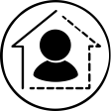

How to get tested
- Find your nearest testing centre at www.healthpoint.co.nz/covid-19 or call Healthline on 0800 358 5453
- It’s free
- Tell them you’re a Close Contact and you are feeling unwell
What it means to self-isolate
- Stay away from other household members if possible
- Don’t leave your house for any reason
- You can’t have any visitors
For more information, go to www.health.govt.nz/our-work/diseases-and-conditions/covid-19-novel-coronavirus/covid-19-health-advice-public/covid-19-self-isolation-managed-isolation-quarantine#whattodo

Symptoms of COVID-19
- A new or worsening cough
- Sneezing and runny nose
- A fever
- Temporary loss of smell or altered sense of taste
- Sore throat
- Shortness of breath
Less common symptoms include diarrhoea, headache, muscle aches, nausea, vomiting, malaise, chest pain, abdominal pain, joint pain, or confusion/irritability.
For more information, go to covid19.govt.nz/health-and-wellbeing/about-covid-19/covid-19-symptoms/
For more information on being a Close Contact
www.health.govt.nz/our-work/diseases-and-conditions/covid-19-novel-coronavirus/covid-19-health-advice-public/contact-tracing-covid-19#factsheets
Noho ora mai
[insert name, position and tertiary provider]

3. Template communications for Close Contacts who are secondary/tertiary students (Optional at Phase 3)

- If a provider chooses to undertake Close Contact identification, then this message is to be sent in its to the whānau members of the list of Close Contacts identified by the tertiary provider who are children.
- Highlighted text needs to be edited with relevant public health information or provider details.

[Kia ora/insert greeting]
The health and wellbeing of our students, staff and community is a top priority.
This message contains information about what you and your whānau need to do. Please read it carefully.
We’re sending this message as your child has been identified as a CLOSE CONTACT. They had contact with a positive COVID-19 case at [tertiary provider] on [insert date of last exposure].
You should monitor for symptoms for 10 days from your last exposure to the Case, and if you feel unwell you should remain at home and get tested.
[Optional paragraph] While Close Contacts are not required to self-isolate at Phase 3 (unless they are a Household Contact) we are asking whether your child would be willing to learn remotely for [X] days since your last exposure to the Case. While this is completely optional, it could help to slow the spread of COVID-19 within the tertiary community.
If you have received different advice to that below (e.g. through a text), please follow that advice.
If you have questions, you can contact [insert details eg, name/role/number/email address].

A COVID-19 case has been confirmed in your
tertiary education community.
YOUR CHILD has been identified as a CLOSE CONTACT
Please follow this Public Health guidance.

Close Contacts are not required to self-isolate, but you should MONITOR YOUR CHILD’S SYMPTOMS FOR 10 DAYS from the date of their contact with the case.
- If you child feels unwell, they should stay at home and get tested.
- If they return a positive test, then they are a Confirmed Case and you must all self-isolate as Household Contacts.
- Follow public health advice on the Ministry of Health website: www.health.govt.nz/covid-19-contact

HOW TO GET TESTED
- Find your nearest testing centre at www.healthpoint.co.nz/covid19 or call healthline on 0800 358 5453
- It’s FREE
- Tell them your child is a CLOSE CONTACT and they are feeling unwell
WHAT IT MEANS TO
SELF-ISOLATE
- Stay away from other household members if possible
- You can’t have any visitors

How to get tested
- Find your nearest testing centre at www.healthpoint.co.nz/covid-19 or call Healthline on 0800 358 5453
- It’s free
- Tell them your child is a Close Contact and is feeling unwell
What it means to self-isolate
- Stay away from other household members if possible
- Don’t leave your house for any reason
- You can’t have any visitors
For more information, go to www.health.govt.nz/our-work/diseases-and-conditions/covid-19-novel-coronavirus/covid-19-health-advice-public/covid-19-self-isolation-managed-isolation-quarantine#whattodo

Symptoms of COVID-19
- A new or worsening cough
- Sneezing and runny nose
- A fever
- Temporary loss of smell or altered sense of taste
- Sore throat
- Shortness of breath
Less common symptoms include diarrhoea, headache, muscle aches, nausea, vomiting, malaise, chest pain, abdominal pain, joint pain, or confusion/irritability.
For more information, go to covid19.govt.nz/health-and-wellbeing/about-covid-19/covid-19-symptoms/
For more information on being a Close Contact
www.health.govt.nz/our-work/diseases-and-conditions/covid-19-novel-coronavirus/covid-19-health-advice-public/contact-tracing-covid-19#factsheets
Noho ora mai
[insert name, position and tertiary provider]

4. Template communications for the rest of the tertiary community (Optional at Phase 3)

- It is up to the tertiary provider to determine who should receive a community wide letter.
- Highlighted text needs to be edited with relevant public health information and provider details.

[Kia ora/insert greeting]
The health and wellbeing of our students, staff and community is a top priority.
We’re sending this message as there is a confirmed case of COVID-19 in our community. The [student/staff member] was at [tertiary provider] from [insert relevant dates]. At Phase 3 of the Omicron response, only Cases and Household Contacts need to self-isolate. You can still come to [tertiary provider].
What you need to do
- You and your whānau should watch for symptoms
- If any develop, get tested immediately
- Then, stay at home until you receive the result (if you were tested via a PCR test)
- If you or your whānau haven’t had their booster yet, please do so as soon as possible. You can book online at bookmyvaccine.nz or by calling 0800 28 29 26. It’s free.

What we’re doing
- [Tertiary provider] will stay open
- We have appropriate public health measures and cleaning procedures in place

Symptoms of COVID-19
- A new or worsening cough
- Sneezing and runny nose
- A fever
- Temporary loss of smell or altered sense of taste
- Sore throat
- Shortness of breath
Less common symptoms include diarrhoea, headache, muscle aches, nausea, vomiting, malaise, chest pain, abdominal pain, joint pain, or confusion/irritability.
For more information, go to covid19.govt.nz/health-and-wellbeing/about-covid-19/covid-19-symptoms/.
Please contact [insert details eg, name/role/number/email address] if you have any questions.
Noho ora mai
[insert name, position and tertiary provider]

Appendix Two: Social media template: Tertiary provider informing community about confirmed case

- General heads-up – choose one from the two options/scenarios

  - Scenario 1 – Only specific classes will move to distance learning, the rest of the provider is still open onsite

Text | IMAGE
There are multiple confirmed COVID-19 cases in our community.  We have decided to move to distance learning for [insert relevant classes] for [expected amount of time].  If you are in one of those classes, please continue your studies from home until we provide you with an update. | 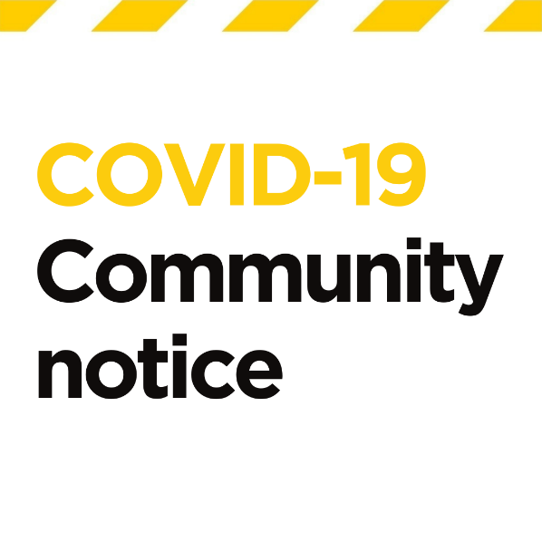

  - Scenario 2 – the whole provider moves to distance learning

There are multiple confirmed COVID-19 cases in our community.  All classes in our provider will move to distance learning for [expected amount of time]  Please continue your studies from home until we provide you with an update. | 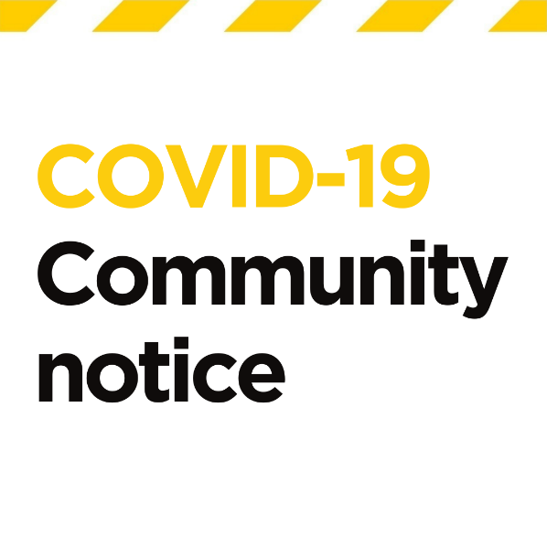

Appendix Three: Checklist for preparedness

Actions to take now | Answers
Have you supported all staff and students to have their COVID vaccination, and encouraged them to get boosters when they are eligible?
Have you supported your regular visitors (and their families) to have their COVID vaccination, including boosters?
Have you contacted your DHB to see how they can help you support non-vaccinated people to access vaccine information or to get vaccinated?
What processes do you have in place to ensure that unwell staff and students stay home?
Have you identified staff willing and able to be redeployed to undertake immediately mission critical work?
What processes do you have in place to ensure that staff and students can work or study from home if they are required to isolate?
How do you ensure that your staff and students wear masks?
More information about use of masks, including appropriate types of masks can be found on www.health.govt.nz/covid-19-health-advice-public/covid-19-use-masks-and-face-coverings-community#types.
Do you promote good hygiene procedures?
- Washing hands before and after eating and toileting
- Hand sanitiser or soap/water and paper towels available
- Avoiding hand-to-face activities where possible
Have you maximised opportunities for fresh air?
- Ventilating indoor spaces
- Outdoor learning spaces
Have you considered how to minimise interactions between students?
- Class bubbles, staggered timing or movement restrictions to manage corridor congestion
Have you considered how residents or staff could self-isolate in their hall of residence?
Have you checked in with staff and students who are medically vulnerable (eg. significant health conditions and unvaccinated, or vaccinated but immunocompromised), to see how the provider can support them to avoid exposure?
How are you configuring your teaching and learning spaces to minimise contacts?
How will you rapidly identify contacts for contact tracing purposes if there is a case on-site?
Have you encouraged staff and students to turn on Bluetooth on the NZ COVID Tracer App? This will help to identify Close Contacts.

Appendix Four: Frequently asked questions
All or some of our students and staff are already fully vaccinated. Do they still need to follow your advice?
Yes. The vaccine is a good protective measure, but no vaccine is 100% effective. You may still get ill or pass the virus to others even if you don’t have symptoms. It’s important to follow the public health advice given.

Boosters are now encouraged for all those eligible to receive them. While a 2-dose course provides some protection against severe disease from the Omicron variant, a booster is likely offer greater protection by reducing the chance of more serious infection and the risk of transmitting it to others.

What welfare support will be available for staff or students who need to isolate?
As people who need to self-isolate cannot get groceries or other essentials, support is available and can be accessed by those who need help. There will also be regular checks by health agencies and other providers, through phone calls or texts, to make sure those self-isolating are safe.

If you need extra support, see covid19.govt.nz/isolation-and-care/getting-extra-support-if-you-have-covid-19-or-are-self-isolating/.

Some of our students or staff are at higher risk of illness. What should we do?
Some people, such as pregnant women or those who are medically vulnerable (eg, with significant health conditions and unvaccinated, or vaccinated but immunocompromised), may be at higher risk of serious illness from COVID-19. If people are concerned, they should seek the advice of their health professional or call Healthline on 0800 358 5453.

Do we need to undertake a deep clean of our site?
The cleaning requirements are outlined on the Ministry of Health website www.health.govt.nz/our-work/diseases-and-conditions/covid-19-novel-coronavirus/covid-19-information-specific-audiences/covid-19-general-cleaning-and-disinfection-advice. There is also specific advice for businesses and education entities on this page.

Current evidence suggests that catching COVID-19 from surfaces is not common, but it is still important to clean surfaces to reduce the risk. The length of time the virus can survive on surfaces depends on many factors including temperature, humidity and UV or sunlight.

For some frequently asked cleaning questions, see www.health.govt.nz/our-work/diseases-and-conditions/covid-19-novel-coronavirus/covid-19-information-specific-audiences/covid-19-general-cleaning-and-disinfection-advice/covid-19-cleaning-frequently-asked-questions.

What if the case was smoking/vaping?
When smoking or vaping, people tend to blow air and particulates out of their lungs more forcefully than during normal breathing, which may increase the risk of COVID-19 transmission. They also will have removed their mask to smoke/vape, so people near them (indoors) are likely to be Close Contacts. At Phase 3, Close Contacts are not required to self-isolate (unless they are also Household Contacts).

Who can we contact about the public health actions at our tertiary education provider?

The relevant Single Point of Contact is your first port of call.

Where can we find more COVID-19 information and resources?
For more information please visit:
- www.education.govt.nz/covid-19
- www.health.govt.nz/covid-19
- www.covid19.govt.nz
If you or someone in your household develops symptoms, please call Healthline on 0800 358 5453. Healthline is a free and 24/7 service and has interpreters available.

Appendix Five: Scenarios to support contact categorisation

If a provider chooses to undertake Close Contact identification at Phase 3, then the following scenarios should help assist with correctly categorising contacts once they have been identified. Students of staff who are identified as Close Contacts are not required to self-isolate, but providers may ask them to consider learning or working remotely for a period of time to help slow the spread of COVID-19 in the tertiary community.

Note that contact categorisation changes if the COVID-19 case was wearing a mask while infectious.

Scenario | Contact Categorisation
Scenario 1  A case was working in a research lab, indoors, with 5 other people all day. They maintained 1.5m distancing all day. | NO MASKS USED  - If the case wasn’t wearing a mask: others in the lab would be CLOSE CONTACTS  MASKS USED  - If the case was wearing a mask: others in the lab would be CASUAL CONTACTS  See Appendix Four: Higher risk indoor contact more than 1.5m away from case and no close-range contact
Scenario 2  A case was working between a research lab and a computer lab all day, with other staff/students coming in and out of both throughout the day. | NO MASKS USED  - If the case wasn’t wearing a mask: others in the lab for any period of time would be CLOSE CONTACTS  MASKS USED  - If the case was wearing a mask: others in the labs would be CASUAL CONTACTS  See Appendix Four: Close range contact within 1.5m of case
Scenario 3  A case attended a trip offsite to undertake research field work. The field work was mostly outdoors but they travelled to the site with other researchers. | Contact in outdoor spaces is considered to be low-risk contact.  For the time spent travelling in a vehicle with other researchers:  NO MASKS USED  - If the case wasn’t wearing a mask: others who travelled together in the same vehicle with the case would be CLOSE CONTACTS  MASKS USED  - If the case was wearing a mask: others in the research group would be CASUAL CONTACTS  See Appendix Four: Higher risk indoor contact more than 1.5m away from case and no close-range contact
Scenario 4  A case attended an outdoor practical class (eg horticulture) with their tutor and 10 other students. They all make their own way to the class and eat lunch outside. | Contact in outdoor spaces is considered to be low-risk contact. All students and the tutor would be: CASUAL CONTACTS  See Appendix Four: Low risk contact (no close-range contact or higher risk indoor contact)  Other things that may be important to consider:  - how did the students and tutor get to the class?  - did they share transport?
Scenario 5  A case attended a large lecture (100+) indoors for 50 minutes. | If the case is either a student or the lecturer, for those that were within 1.5m of the case:  NO MASKS USED  - If the case wasn’t wearing a mask: others within 1.5m for any period of time would be CLOSE CONTACTS  MASKS USED  - If the case was wearing a mask: others in the room would be CASUAL CONTACTS  See Appendix Four: Close range contact within 1.5m of case
For the rest of the people in the lecture more than 1.5m away from the case, if the room had poor airflow/ventilation:

NO MASKS USED
- If the case wasn’t wearing a mask: others would be CLOSE CONTACTS
MASKS USED
- If the case was wearing a mask: others in the room would be CASUAL CONTACTS

See Appendix Four: Higher risk indoor contact more than 1.5m away from case and no close-range contact
If the room had good airflow/ventilation:
This is considered to be low-risk contact. The rest of the people in the lecture would be: CASUAL CONTACTS

See Appendix Four: Low risk contact (no close-range contact or higher risk indoor contact)
Scenario 6  A case attended a small workshop (30 people) indoors for 2 hours. | NO MASKS USED  - If the case wasn’t wearing a mask: others would be CLOSE CONTACTS  MASKS USED  - If the case was wearing a mask: others in the room would be CASUAL CONTACTS  See Appendix Four: Close range contact within 1.5m of case
Scenario 7  A case studied in the library all day, moving between study areas and the computer lab (multi-level library, 300+ seats) | If none of the high-risk criteria from the contact categorising table are present, contact in large indoor areas is considered to be low-risk contact. All students and staff at the library at the same time as the case would be: CASUAL CONTACTS  See Appendix Four: Low risk contact (no close-range contact or higher risk indoor contact)
Scenario 8  A case hung out with their friends in a large indoor study hub for less than one hour. | NO MASKS USED  - If the case wasn’t wearing a mask: friends within 1.5m for any period of time would be CLOSE CONTACTS  MASKS USED  - If the case was wearing a mask: friends would be CASUAL CONTACTS  See Appendix Four: Close range contact within 1.5m of case
 | For others in the study hub at the same time that are not part of the group of friends, if none of the high-risk criteria from the contact categorising table are present, contact in large indoor areas is considered to be low-risk contact. All other students and staff in the hub at the same time as the case would be: CASUAL CONTACTS
Scenario 9  A case attended office hours with a lecturer in a small office, one on one. Another student went into the office to talk to the lecturer directly after the case. | NO MASKS USED  - If the case wasn’t wearing a mask: the lecturer would be a CLOSE CONTACT  MASKS USED  - If the case was wearing a mask: the lecturer would be a CASUAL CONTACT  See Appendix Five: Close range contact within 1.5m of case
 | The student who went into the office directly after the case is unlikely to be a contact.
Scenario 10  A case (a member of the public) got a haircut from a student at a polytech run hair salon. The appointment was 45 minutes. | NO MASKS USED  - If the case wasn’t wearing a mask: the student and others in the hair salon would be CLOSE CONTACTS  MASKS USED  - If the case was wearing a mask: student and others in the salon would be CASUAL CONTACTS  See Appendix Four for details: Indoor face to face contact for more than 15 minutes OR Indoor contact in a small space without good airflow/ventilation* for more than 15 minutes
Scenario 11  A case worked in their office alone all day with the door closed, with short breaks in the communal kitchen (less than 15 mins). | Any contacts in the kitchen that didn’t meet any of the high-risk criteria in the contact categorising table, any brief contacts would be: CASUAL CONTACTS  See Appendix Four: Brief indoor contact regardless of distance from case
Scenario 12  A case went to the gym to work out for 45 minutes and maintained physical distancing where possible. They were not wearing a mask. | As masks are not required in gyms, and working out means there is likely to be heavy breathing, anyone at the gym at the same time as the case would be: CLOSE CONTACTS
Scenario 13  A case played a game of basketball at an indoor sport facility for 1.5 hours, with spectators. | Everyone playing basketball will be a: CLOSE CONTACT  - It doesn’t matter how long somebody was in close range with the identified case  - It doesn’t matter if the case was wearing a mask or not  See Appendix Four for details: Direct contact with respiratory secretions or saliva (indoors or outdoors) OR Face to face contact with a case who is forcefully expelling air/secretions FOR ANY DURATION OF TIME
Depending on the size of the indoor sport facility and if there is good ventilation, the spectators may be categorised differently.
For a moderate sized space without good airflow/ventilation:
NO MASKS USED
- If the case wasn’t wearing a mask: spectators would be CLOSE CONTACTS
MASKS USED
- If the case was wearing a mask: spectators would be CASUAL CONTACTS
If the indoor sport facility is a large space (bigger than 300m²) or is a smaller space with good airflow and ventilation:
- Spectators would be: CASUAL CONTACTS
Scenario 14  A case was onsite and indoors at a business for one day to compete the practical component of their study. They had interactions with other workers in the business but no customers. They were within 1.5m at various times throughout the day and were not required to wear masks. | As no mask were worn, and there were close interactions over the course of a day indoors, anyone at the business at the same time as the case would be: CLOSE CONTACTS  See Appendix Four for details: Indoor face to face contact for more than 15 minutes OR Indoor contact in a small space without good airflow/ventilation* for more than 15 minutes  As the contact with the case happened at a business not at a tertiary provider, the contact tracing process would need to be undertaken by the business. If the case had also been at the tertiary provider while infectious, then the provider would need to identify contacts in their setting.
For additional scenarios on Tertiary Accommodation, please refer to the separate guidance on student accommodation available at Te Mahau | Resources for tertiary education providers.

For masks to be effective, it is important they are of sufficient quality (medical or multilayer cloth masks) are worn. Mask breaks are recommended to improve compliance over a workday. Masks should be changed if they become wet or dirty.

